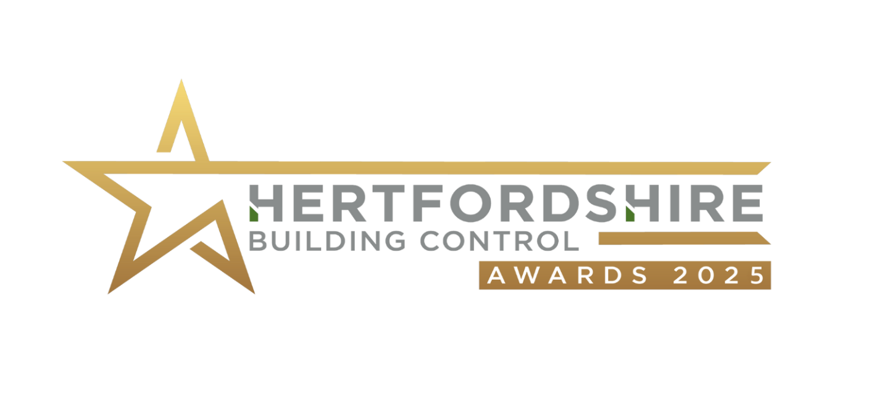

**HBC Place Awards** **2025  
(Sites Completed Jan -Dec 2024)**

**Building Control Surveyor Information**

First name

Last Name

Job Title

Company

Email

Mobile

**Please highlight the category you are entering this project into**

*Projects can only be entered into one category*

* Residential – Best extension/conversion/alteration to an existing home
* Residential – Best individual new home
* New Housing – Best new housing development (1-9 units)
* New Housing – Best new housing development (10+ units)
* Non-residential – Best extension/alteration/new build

**Description of project:** eg single-storey extension/residential development of x dwellings

**Project Address**

**Number of plots**

**Completion date**

*This is the date that the project was completed on-site*. **: DD/MM/2024**

**Project Photos**

Please upload a minimum of 3, maximum of 6 hi-res photos (ideally 300dpi or 2000 pixels)

Take them on a sunny day if possible so they show the project at its best!

***Nomination***

1. **Why does this project deserve to win?** (200 – 500 words)

*You could consider the following to build your nomination:  
What is special or unique about the project?   
Was the project delivered on time and on budget?   
Was the client happy with the project?   
Did this project excel in sustainability or in exceeding Part M?*

*Examples of how the design and/or site team and building control team worked well together?*

*Give an example of a design problem or site problem that the team overcame.*

**Project Team Members**

*In this section you’ll be giving details of the team members involved in the project.*

**Contractor Company**

Name

Job Title

Company

Email

Telephone

Company Social Media Profiles

Address

**Architect/designer Company**

Architect/designertitle

Name

Job title

Company

Email

Telephone

Company Social Media Profiles

Address

**Client**

Name

Job title

Company

Email

Telephone

Address